**Designed a MATLAB-based fitness tracker to estimate distance covered, step count, and calories burned.**

**OBJECTIVE:**

To develop a MATLAB-based fitness tracker that calculates the number of steps taken, distance covered, and calories burned based on user input or simulated step data. The project aims to promote health awareness through a simple, lightweight computational model.

**Tools & Technologies Used**

* **Software:** MATLAB
* **Programming Language:** MATLAB Script (.m files)
* **Techniques Used:** Looping, Conditional Statements, Basic Formulas for Calorie Estimation
* **Output:** ThingSpeak

**WORKFLOW:**

**User Input / Step Data Simulation**

* Number of steps entered or simulated

**Distance Calculation**

* Based on steps

**Calories Burned Estimation**

**Output Display**

* Distance walked, calories burned, and summary displayed in ThingSpeak

**Sample Ouput:**

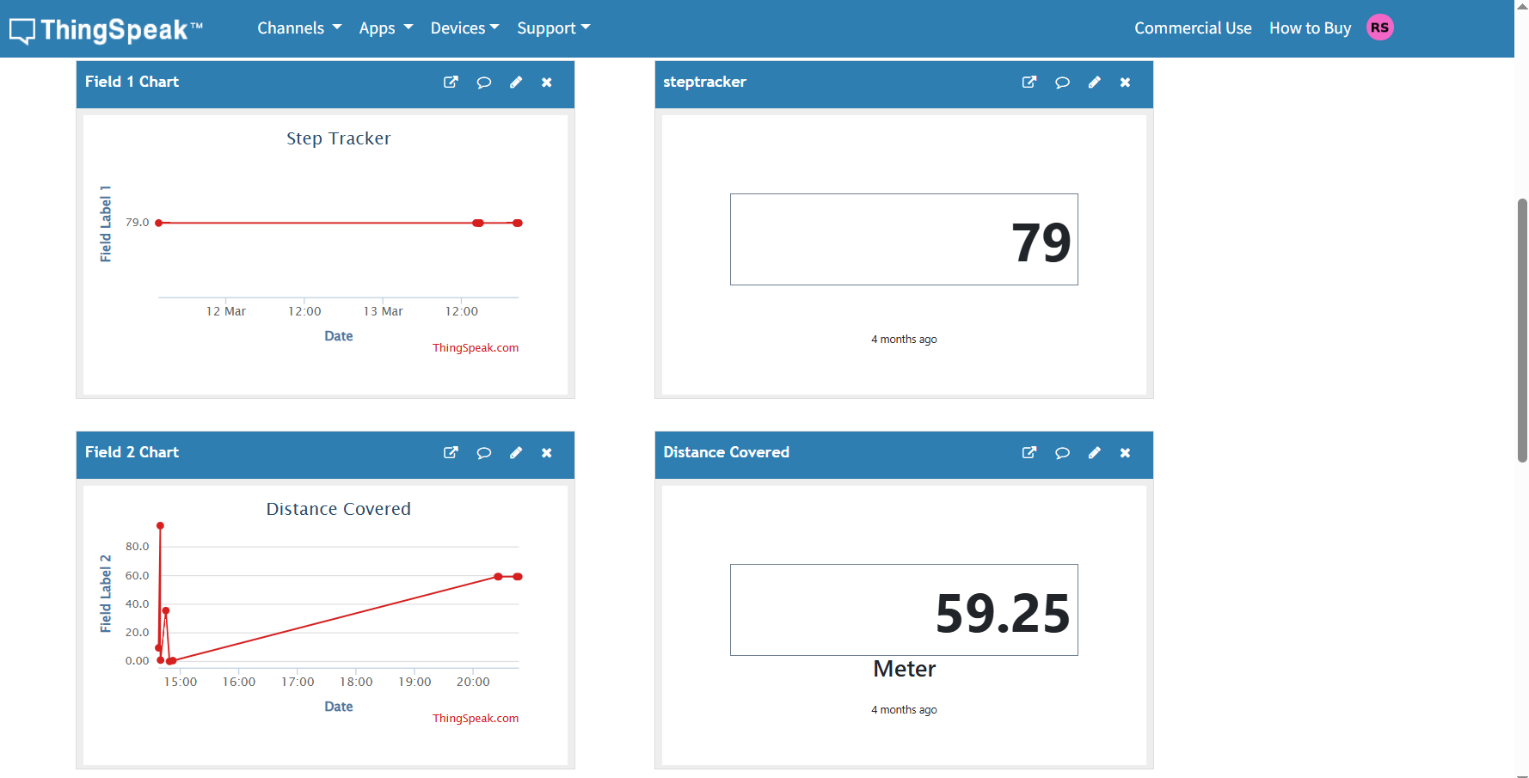

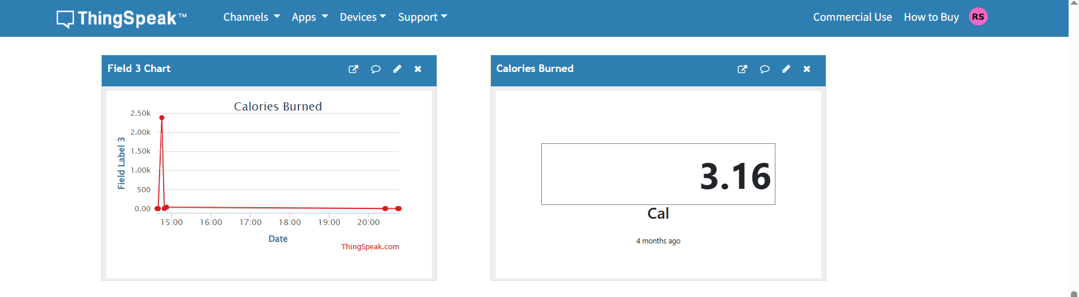

**Demo & Source Files Link:**

You can access the complete project materials using the link below. The folder contains:

* Project Source Code
* Demo Video of the Project

**Google Drive Link:**

<https://drive.mathworks.com/sharing/d642af53-457e-4e08-9c58-50f352cf0070>

**ThingSpeak link to see Output:**

<https://thingspeak.mathworks.com/channels/2872948>